Phase 3: Service Desk Simulations & Management (Build Your Routine)
This document outlines the steps and outcomes for two key lab activities: Active Directory User & Group Management and Group Policy Objects (GPOs) Implementation. These labs focus on building a foundational Active Directory structure and implementing centralized management policies.

## Activity 1: Active Directory User & Group Management
This activity involved organizing users and groups within Active Directory, a critical task for any system administrator. We set up Organizational Units (OUs), created user accounts, and established security groups to reflect a typical corporate structure.
📝 Steps and Documentation
First, I logged into DC01 as a domain administrator and opened the Active Directory Users and Computers (ADUC) console.
- Organizational Units (OUs): I created OUs to logically structure the domain. These OUs were Sales, Marketing, IT, and Managers.
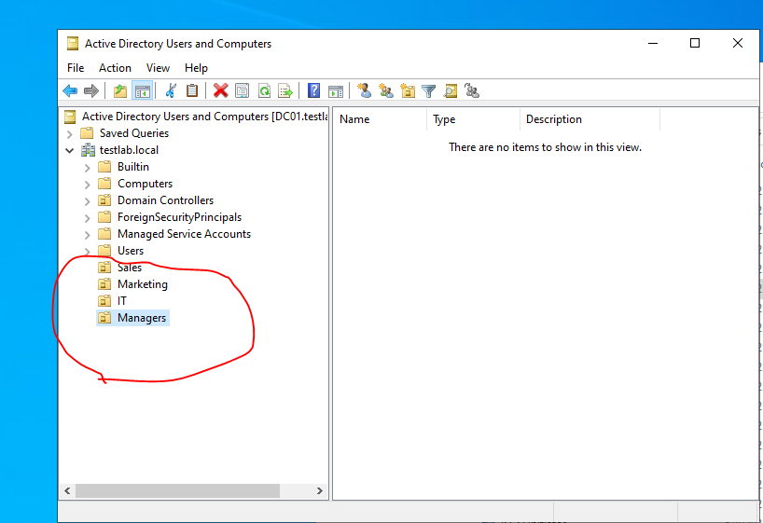
- User Creation: I created several user accounts and placed them in their respective OUs. For example, Jane Doe was placed in the Sales OU and John Smith in the Marketing OU. A total of 5 users were created with unique usernames and initial passwords.
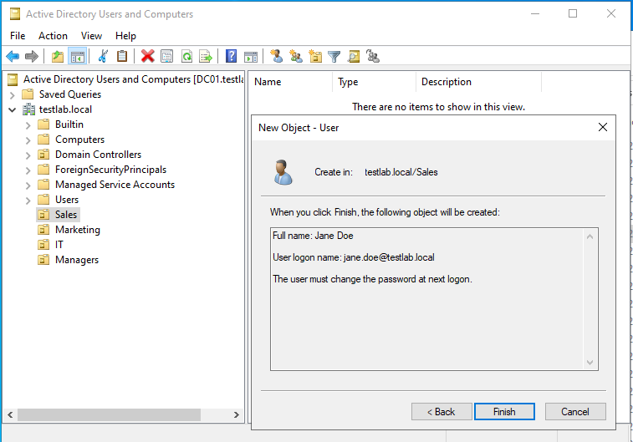

- Security Groups: I created four security groups to manage permissions efficiently: Sales_Dept, IT_Team, Marketing_Dept, and Managers_Group.
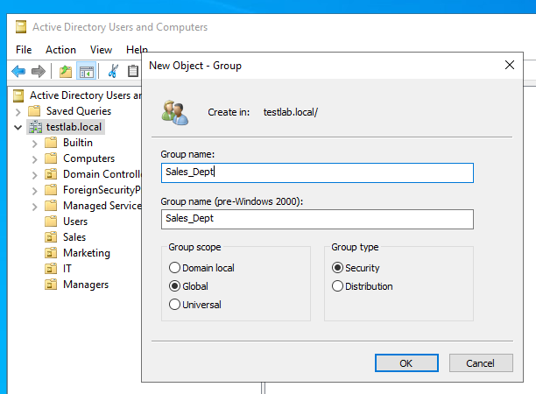
- Adding Users to Groups: Users were added to the appropriate groups. For instance, jane.doe was added to Sales_Dept, and itadmin was added to IT_Team.
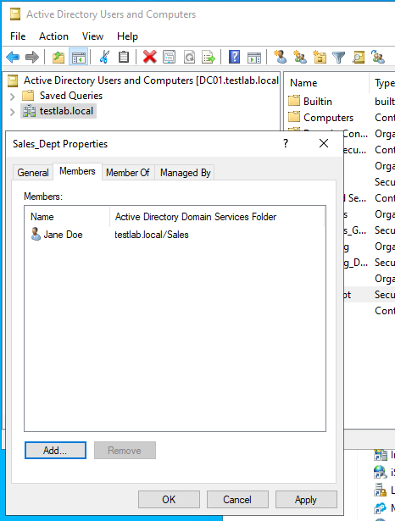
- User Login Verification: I tested user logins on the W10-Client01 VM. Each new user's successful login created a corresponding user profile folder in C:\Users\. This confirmed that the users were properly authenticated by the domain controller.
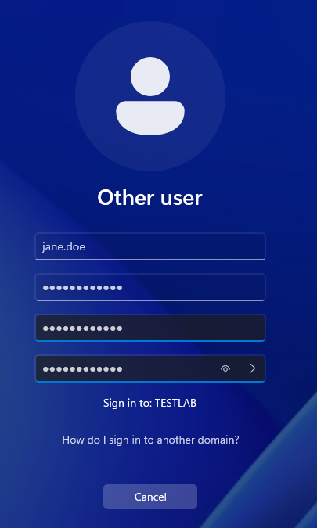
- PowerShell User Creation: I created a PowerShell script to automate user creation from a CSV file. The script reads user details and creates the accounts and adds them to groups in Active Directory.
  - PowerShell Script: The script uses the Import-Csv and New-ADUser cmdlets to create users efficiently. I saved the script and a sample CSV file.
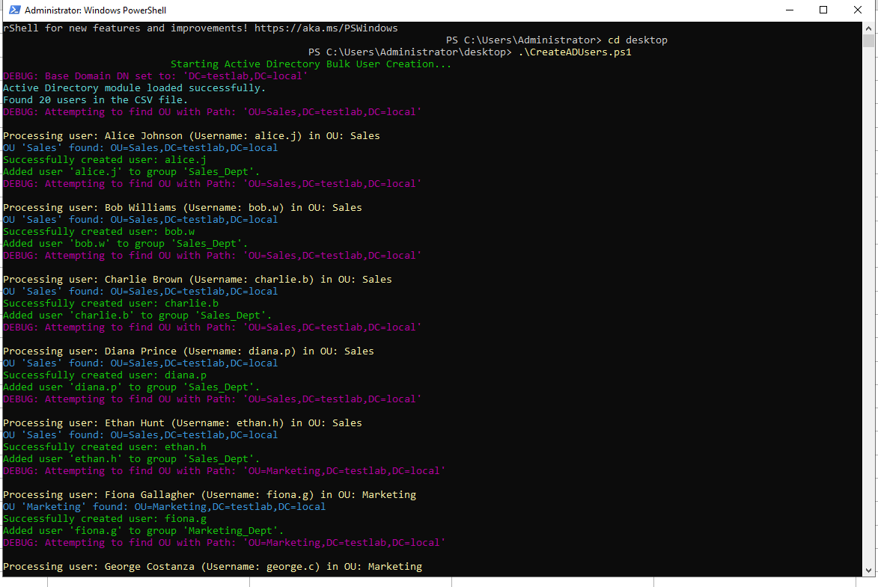
  - Script and Repository: I've uploaded the PowerShell script to a GitHub repository for version control and sharing.
  - Link to GitHub Repository: [Insert link to your GitHub repository here]
  - Verification: The script successfully created the users from the CSV file, which was confirmed by viewing the new accounts in the ADUC console.
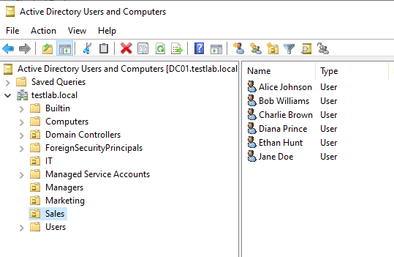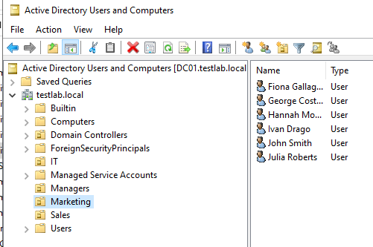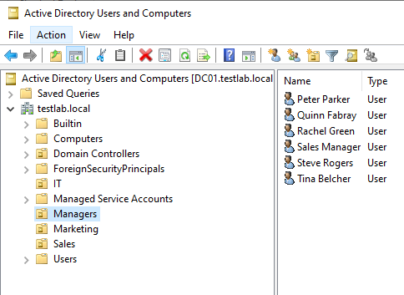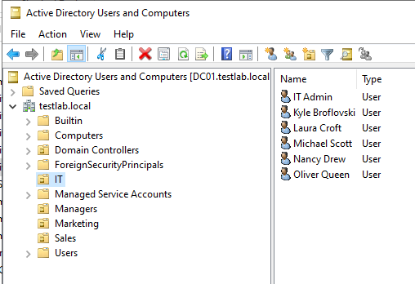

## Activity 2: Group Policy Objects (GPOs) Implementation
This activity focused on using Group Policy Objects (GPOs) to enforce centralized settings, enhance security, and customize user environments.
📝 Steps and Documentation
I logged into DC01 and opened the Group Policy Management console.
- Password Policy GPO: I modified the Default Domain Policy to enforce a strong password policy. The settings included a minimum password length of 10 characters, a password history of 24 passwords, and password complexity requirements.
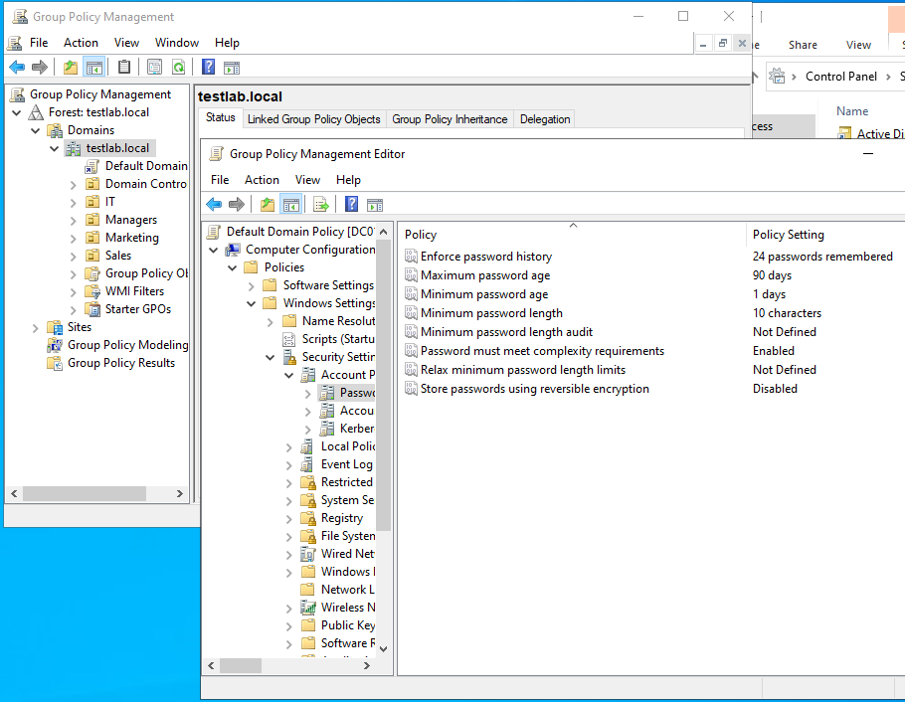

  - GPO Configuration: These settings were applied to Computer Configuration -> Policies -> Windows Settings -> Security Settings -> Account Policies -> Password Policy.
  - Verification: On the W10-Client01 VM, a gpupdate /force was run. Attempting to change a user's password to a simple value (e.g., "abc") failed, confirming the policy was in effect.
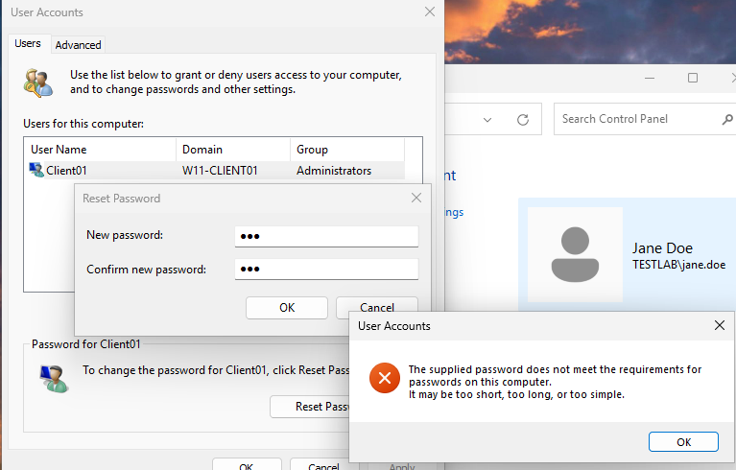
- Desktop Customization GPO: I created a new GPO named Sales_Desktop_Policy and linked it to the Sales OU. This GPO was designed to customize the desktop for all users in that organizational unit.
  - Shared Folder: I created a shared folder \\DC01\CompanyResources containing an image file for the desktop background.
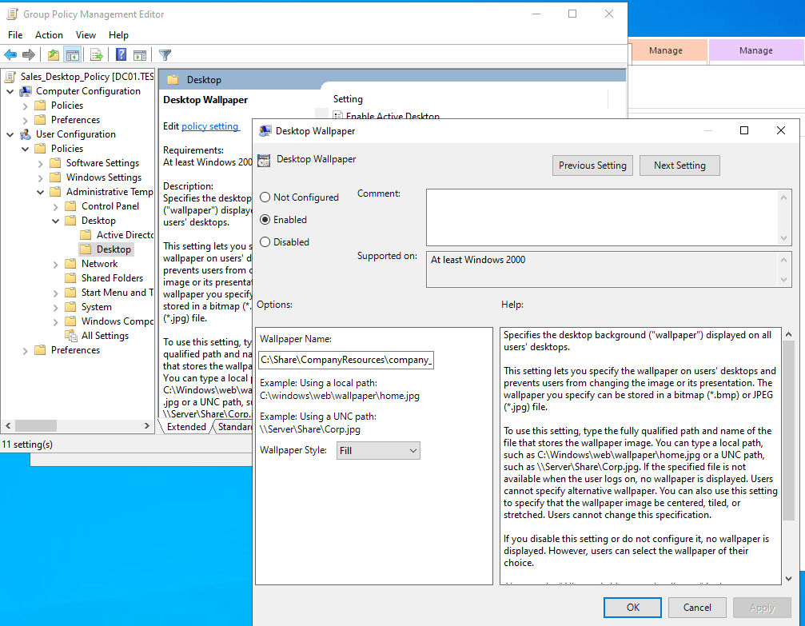
  - Desktop Wallpaper: In the GPO's User Configuration, I enabled the Desktop Wallpaper setting and pointed it to the UNC path of the shared image file.
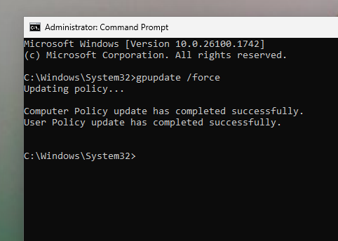
  - Disabled Control Panel Access: I also disabled access to the Control Panel and PC settings to restrict user changes to the system.
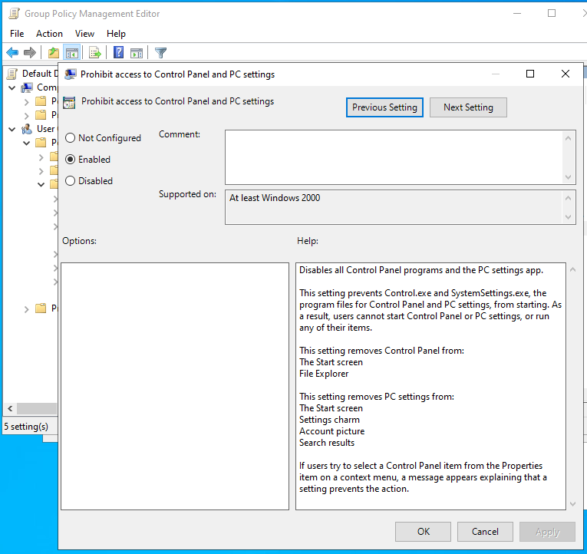
- Verification: I logged in to W10-Client01 as jane.doe (a user in the Sales OU). After running gpupdate /force and logging back in, the following was observed:
  - The desktop background was successfully changed to the corporate image.
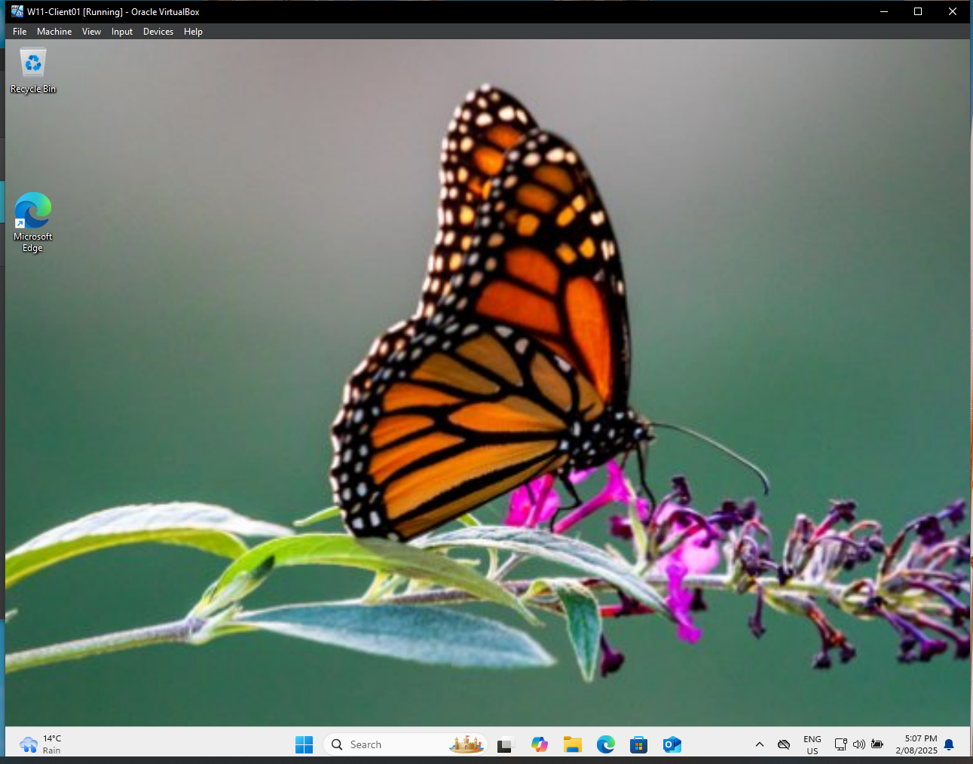
  - Attempts to open the Control Panel or PC settings were blocked with an error message, confirming the GPO was working as intended.
